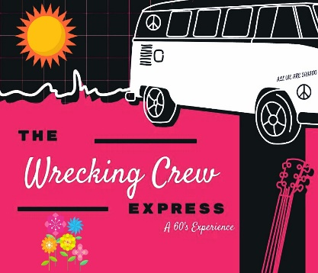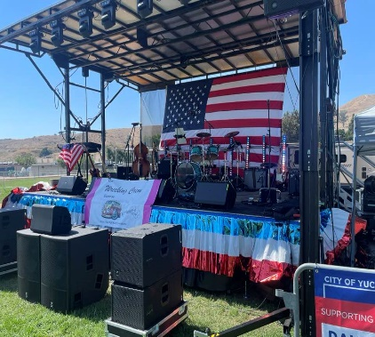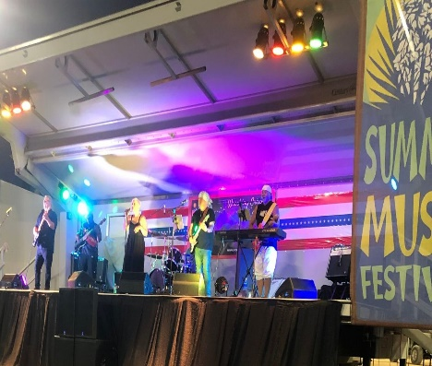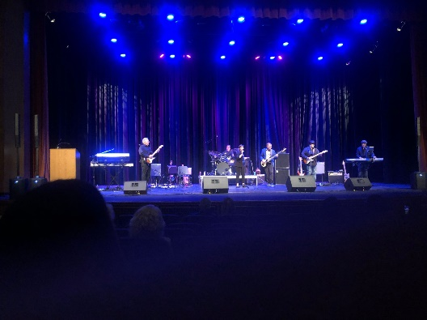

The Wrecking Crew Express
We are now booking performances for the Spring, Summer, Fall & Winter seasons 2025!
While playing a diverse line-up of Classic Rock and Roll from the Sixties & Seventies, the band offers a unique fusion of Oldies.

The Award-winning WCE - Performing songs from these artists and more:
The Beatles, Rolling Stones, Mama and Papas, Elvis Presley, Sonny and Cher, Santana, Ritchie Valens, Chuck Berry, James Brown, Beach Boys, Eric Clapton, BB King, America, The Crystals, Ray Charles, Sam and Dave, Supremes, Janis Joplin, Van Morrison. The Turtles, Scott McKenzie, Doors, Temptations, Gloria Gaynor, Sister Sledge, Tim McGraw, Keith Urban, Carrie Underwood, ZZ Top, Three Dog Night, Queen
Thank You in advance for your consideration.
To book direct please email me or visit our website for more information: www.wreckingcrewexpress.com
Gary Clifford – Band Manager WCE – Redlands, Ca. (909) 556-6438 gwcliff@hotmail.com

